Read the following text carefully.
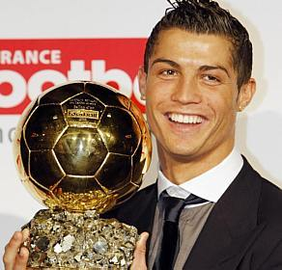
Cristiano Ronaldo dos Santos Aveiro is one of the most popular football players in the world. He was born in Funchal, an island of Madeira, on 5th February, in 1985. His mum, Maria Dolores is a cook. He has got a brother called Hugo and two sisters, Elma and Cátia. He plays football for Real Madrid, so he lives in Madrid, Spain. He is very handsome. He is tall and slim. He has got an oval face and big brown eyes. He has got short wavy brown hair. He is very rich and he loves football.
He is always very busy. He always gets up at six o’clock and runs 5 kilometres. Then he has a shower and at half past seven he has breakfast. At breakfast he has fruit juice and toast. Then he drives to work. He often starts training with his colleagues at eight o’clock.
He usually has lunch at noon in a restaurant with his friends. He eats chicken with pasta and vegetables. He loves healthy food but he hates fast food. He doesn’t like hamburgers and chips. He always drinks water and he doesn’t like alcohol.
He usually arrives home at six o’clock. Before dinner he listens to music because it’s relaxing. He has dinner with his friends at eight o’clock. After dinner, he loves reading and playing PSP. He never goes to bed late.
At the weekend Cristiano Ronaldo usually has important matches and his girlfriend, Irina Shayk, often goes to the matches to see him playing. After the matches he usually visits his son, Cristiano Ronaldo Junior.

A- Are the following sentences TRUE or FALSE? Correct the false ones.
1- Ronaldo’s birthday is on 4th February. _________ ______________________________________________________
2- He was born in Madrid. ________ ___________________________________________________________________
3- He has got blond hair. ________ ____________________________________________________________________
4- Cristiano has lunch at midday. ____________ _________________________________________________________
5- He doesn’t like alcohol. ___________ ______________________________________________________________
6- He usually goes to bed late. ___________ ____________________________________________________________
B- Answer the following questions about the text.
- Who is Cristiano Ronaldo?_________________________________________________________________

- What is his mum’s job? ____________________________________________________________________

- How many sisters has he got? ______________________________________________________________

- Where does he live? ______________________________________________________________________

- Does he like playing football? _______________________________________________________________

- What time does he get up? ________________________________________________________________

- What does he have at breakfast?__________________________________________________________

- Does he run before training?_____________________________________________________________

- How does he go to work? ________________________________________________________________

- Where does he have lunch? ______________________________________________________________

- Does he love fast food?__________________________________________________________________

- Why does he listen to music before dinner?_________________________________________________

- Who does he always visit after the matches? ________________________________________________

C- Fill in the gaps with the correct forms of the verbs in brackets using the Simple Present.

Cristiano Ronaldo ___________ (be) a famous football player. _______________ (there to be) always many fans at the stadiums to see him playing. He __________________ (not live) in Portugal, he _______________ (live) in Madrid but he ___________ (love) his hometown. He ______________ (have got) one brother, Hugo. He ______________ (have) a hard job. He _________________ (train) all day. He ______________ (love) sports, but he ________________ (not/play) volleyball.
He ___________________ (not/get up) early on Sundays. He never _______________ (wake up) before ten o’clock. He always _______________ (go) to the church on sundays and he ____________ (pray) to God.

D- Contradict the sentences.
1- Peter has lunch in the school canteen. ______________________________________________________
2- His sister doesn’t go to work. _____________________________________________________________
3- He has got two children. _________________________________________________________________
4- Susan doesn’t study a lot. _______________________________________________________________
5- They are at school. _____________________________________________________________________

E- Rewrite the sentences using the frequency adverbs.

1- Cristiano gets up at 9 o’clock. (never) -__________________________________________
2- He is tired. (always)- _______________________________________________________
3- Irina goes to the matches. (often)- ____________________________________________
4- His friends are at the stadium with him. (always) -_______________________________________________

F- Put the words in the correct order and build complete sentences.

1. football /Cristiano/ Saturdays/on/ plays/.
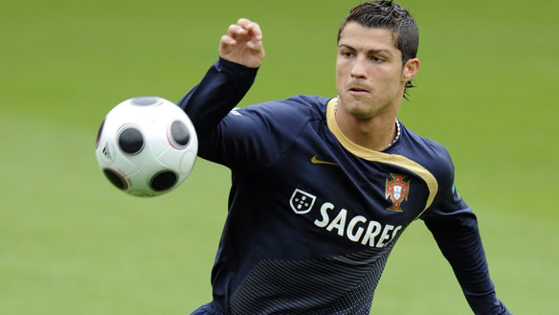
________________________________________________________________________

2. Irina /often/visit/her friends/./ on weekdays
________________________________________________________________________

3. has/He/ breakfast/at 8 o’clock/.
________________________________________________________________________

4. see /His friends/ all his games/usually.
________________________________________________________________________

5. Cristiano/does/play/for/Real Madrid?
________________________________________________________________________

G- What time is it?

1. 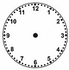 2. 3.
_________________________ _______________________ ___________________________

4. 5. 6.
_____________________________ _________________________ _____________________________

7. 8.
11:20
18:35
________________________ __________________________
H- Ask suitable questions.

- __________________________________________________?
Yes, he does. Ronaldo Junior drinks a lot of milk.

2- ___________________________________________________?
There are twenty people at the party.

- __________________________________________________?
No, she doesn’t. Irina Shayk goes to the gym by car.

- _____________________________________________________?
Hugo is at home because he is ill.
5- ____________________________________________________?
Irina is a famous model.

6- ____________________________________________________?
They have got three children.
I- Write a short composition about your DAILY ROUTINE.
_________________________________________________________________________________________________________________________________________________________________________________________________________________________________________________________________________________________________________________________________________________________________________________________________________________________________________________________________________________________
J– This is what John does every day. Look at the pictures and using the Present Simple write about his daily routine.
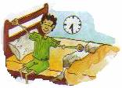
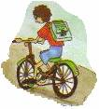
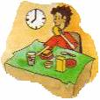
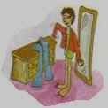

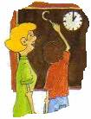
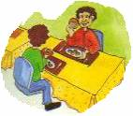
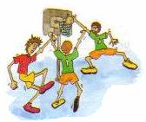
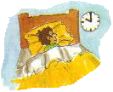

John gets up at half past seven. _____________________________________________________________________
_______________________________________________________________________________________________
_______________________________________________________________________________________________
_______________________________________________________________________________________________
________________________________________________________________________________________________
Marking scheme
A- 6x1=6 points B- 13x2=26 C- 14x1=14 points D- 5x1=5 E- 4x1,5= 6 points
F- 5x1,5= 7,5 points G- 8x1= 8 points H- 6x2= 12 points
I- 7,5 points J- 8 points

C- 1x6=6
D- 1x7=7
E- 2x5=10
F- 1x9=9

