**WORKSHEET: READING**

“Seize the day”  ENGLISH

DEPARTMENT

SUBJECT: ENGLISH

GRADE: FIFTH A- B

TEACHER: VALERIA OJEDA L.

NAME: _______________________________________DATE:____________

Read the texts and the answer.

* **Text 1.-**

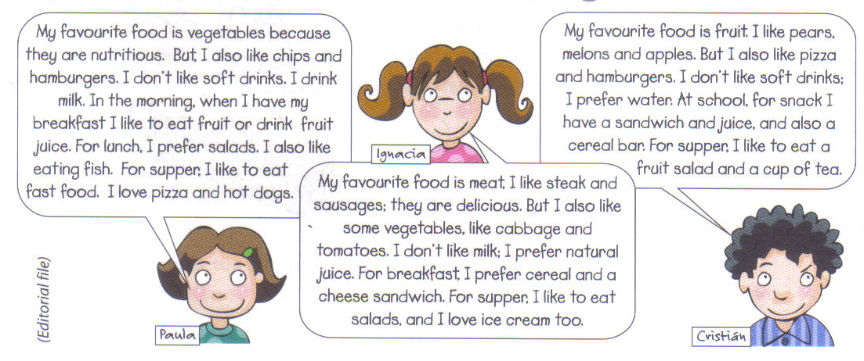

1. Write the correct words from the texts in each group.

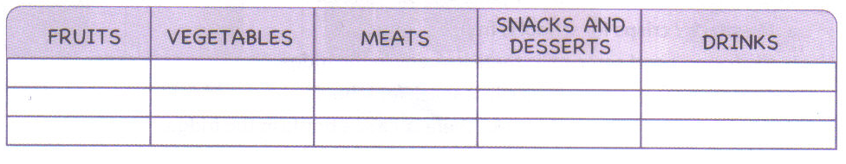

1. True or false. Write T for true sentences or F for false sentences from the text.
2. ________ Paula`s favourite food is meat.
3. 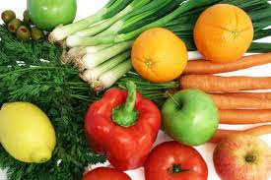________ Paula loves pizza and hot dogs.
4. ________ Ignacia’s favourite food is vegetables.
5. ________ Ignacia likes steak and sausages.
6. ________ Christian’s favourite food is fruits.
7. ________ Christian’s doesn`t like fruit salads.
8. Read and circle the correct answer.
9. **The text is about:**
10. The importance of eating fruit.
11. Different menus for breakfast
12. The food children eat.
13. **Christian’s favourite food is:**
14. Meat
15. Fruit
16. Pears
17. **Ignacia`s favourite food is:**
18. Sausages
19. 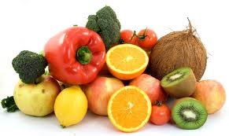Meat
20. Steak and sausages
21. **Paula`s favourite food is:**
22. Chips
23. Salads
24. Vegetables
25. Read and complete the table.

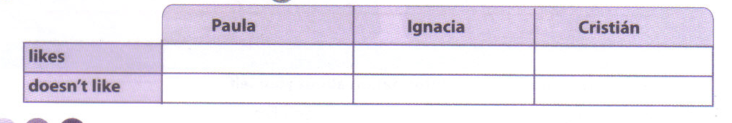

1. Put the words in the correct order.
2. favorite/ My/ is/ potatoes. / food.
3. lunch./ for/ like/ fish/ I _____________________________________________________
4. I/ like/ snack./ sandwiches/ for
5. Complete the sentences with information about yourself.
6. My favourite food is_______________. I don`t like________________.
7. For supper I prefer________________ and _____________________.

**Text 2.-**

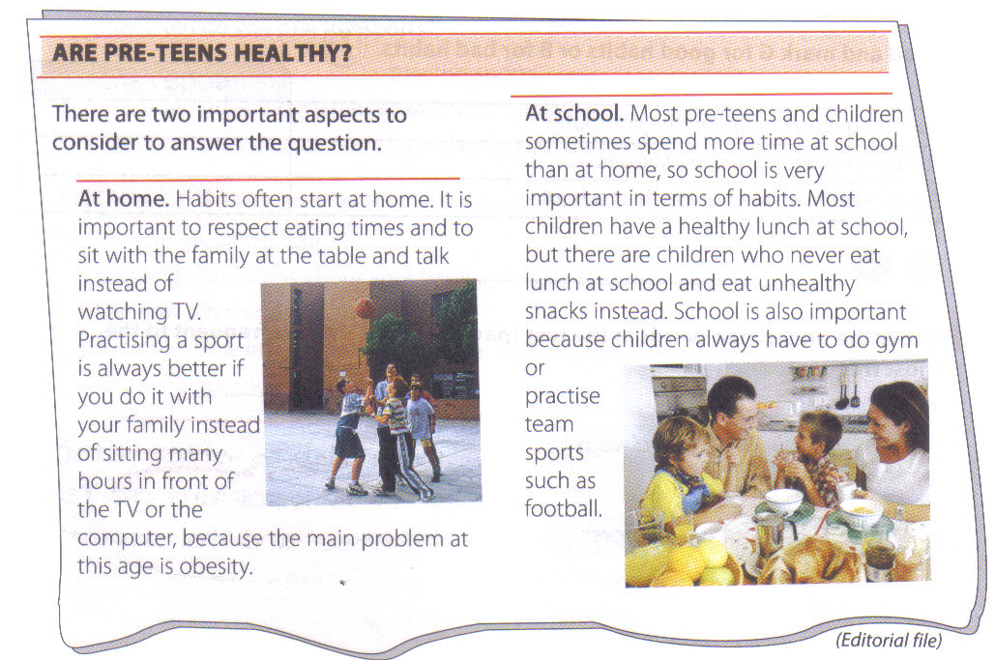

1. 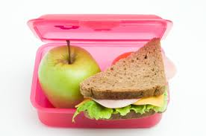Read and write H if happens at home or S if it happens at school.
2. ______ have lunch with your family.
3. ______ practising team sport.
4. ______ having a healthy lunch.
5. ______ having lunch in front of the T.V
6. Read and write Yes or No.
7. ______ Habits never start at home.
8. ______ watching T.V many hours at day is good.
9. ______ snacks are unhealthy food.
10. ______ Students practise sports at school.
11. Underline the best option in each sentence, for good things, and for bad things.

* Spending many hours in the computer. 



* Eating snacks instead of lunch at school. 
* Talking at the table during supper. 
* Practicing sports. 
* Eat salads and fruits. 
* Having lunch with your family. 

1. Order the words to make sentences.
2. always/ I/ at/ practice/ school./ sports
3. often/ Habits/ at/ home./ start

________________________________________________________

1. sometimes/ Students/ lunch/ at/ have/ school.
2. watch T.V/ never/ We/ dinner./ during

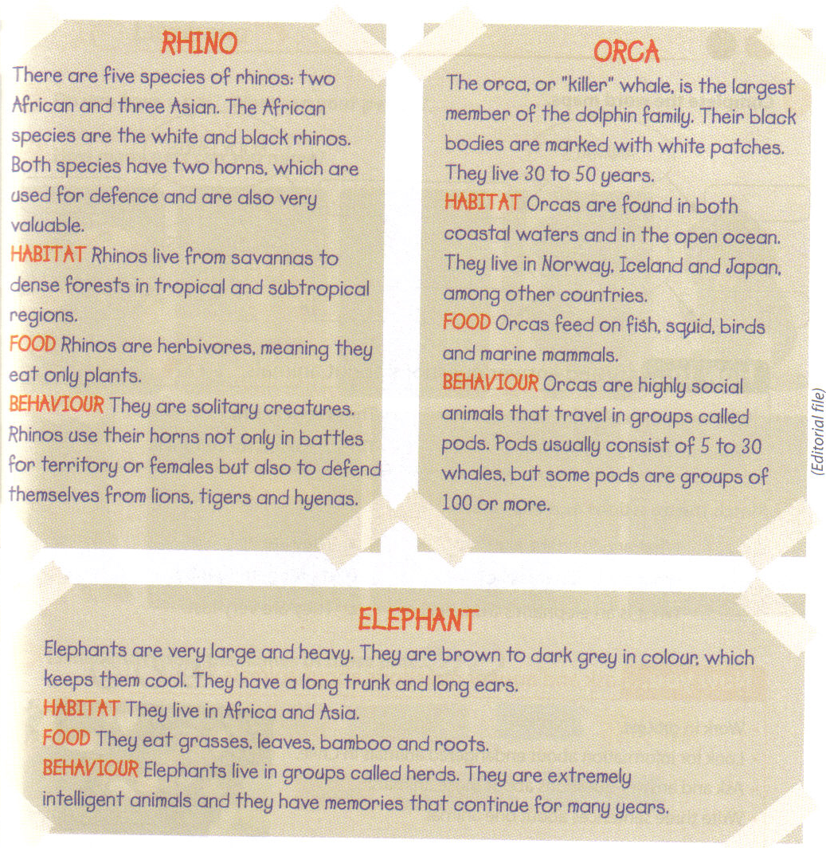**Text 3.-**

1. Read and complete the missing information.

**Information Habitat Food Behaviour**

 Rhino

 Whale

Elephant

1. Match the beginning with the corresponding ending.

**_____** Rhinos live… a) long trunk and ears.

_____ Orcas are… b) grasses, leaves and roots.

_____ Elephants have… c) 30 to 50 years.

_____ Elephants eat… d) social animals.

_____ Orcas live… e) from savannas to dense forest.

1. True or false. Write T for true sentences or F for false sentences from the text.
2. _______ Rhinos are carnivorous.
3. _______ there are five species of rhinos.
4. _______ Orcas live in Norway, Iceland and Japan.
5. _______ Orcas group are called herds.
6. _______ Elephants live only in Africa.
7. _______ Elephants eat grasses, leaves and roots.
8. Match the questions and answers.

______ What are Orcas like? A) They are very big

______ What are Elephants like? B) It is for getting food

______ What is an elephant`s trunk for? C) They have black bodies.

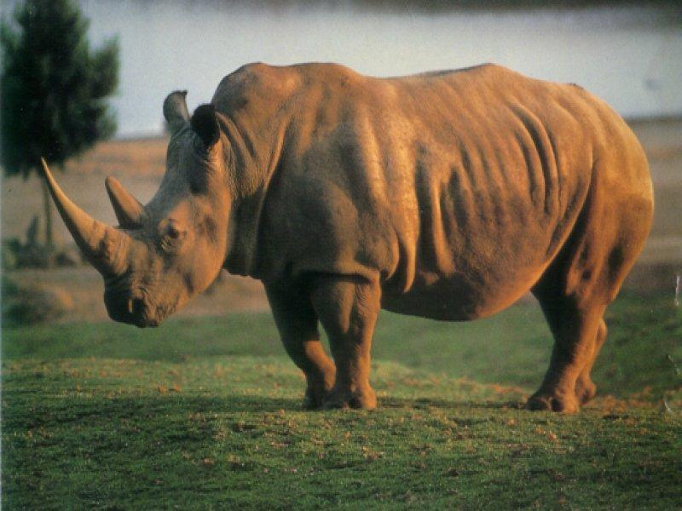

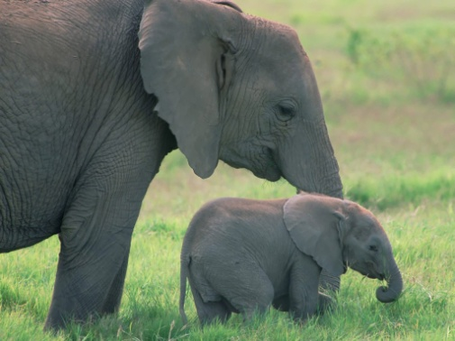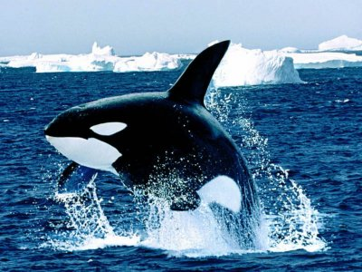

*You can teach a student a lesson for a day; but if you can teach him to learn by creating curiosity, he will continue the learning process as long as he lives. ~Clay P. Bedford*