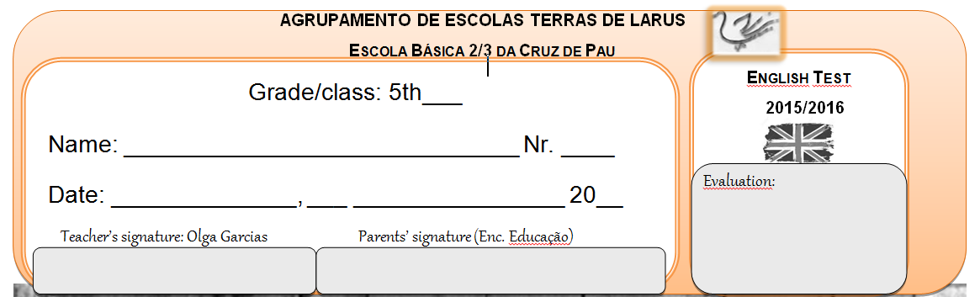

1. Read the text: **My Classroom**

*Hello, my name is Martha and and I am 8 years old. I am Brazilian but I live in Portugal. My house is in Arrentela- Seixal.*

*I study in a private school called Saint Julian’s.*

*I am in 4th grade in Primary level. In our class there are 27 students, 15 girls and 12 boys.*

*My classroom is big and nice. Our teacher is Miss Rachel and she likes decorating the walls of the class with posters and our work. In our class there is a computer and a blackboard.*

*My favourite subject is Mathematics and my favourite animal is the cat. I've got a brown and white cat. Its name is Myau! :)*

*My desk and my chair are brown.* ***On my desk*** *I have my pencil case, it is colourful.* ***In my pencil case I have*** *many things: a red sharpener, two pencils, a rubber, three markers, a glue and a purple pen.*

*I go to school by bus with my best friend Tina. We like our school because there are three playgrounds, a big gym and a fantastic music classroom with many instruments.*

1. **Circle the objects that are in the text:**

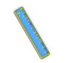

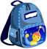

1. **Answer these questions:**

**a) *What’s the school name?***

***……………………………………………………………………………………………………………***

***b) How many boys are there in her class?***

***……………………………………………………………………………………………………………***

***c) What colour are Martha's table and chair?***

***……………………………………………………………………………………………………………***

***d) What objects has Martha got in her pencil case?***

***……………………………………………………………………………………………………………………………***

***e) Are there four or three playgrounds in Saint Julian’s school?***

***……………………………………………………………………………………………………………***

1. **Label the school places.**

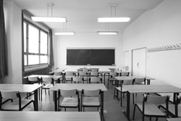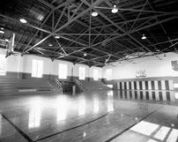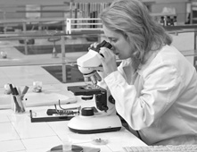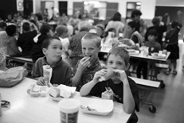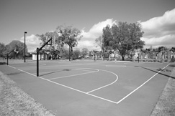

**a)**________________ **b)**_______________ **c)**_______________ **d)**_______________ **e)**_______________

1. **Write the names of the school subjects.**

**a)** sihtryo ____________________ **b)** shtam _____________________ **c)** encsice ___________________

**d)** sicum _____________________ **e)** tar ____________________ **f)** hnegisl _____________________

1. **Prepositions of Place -** Complete the sentences according to the picture on your right:

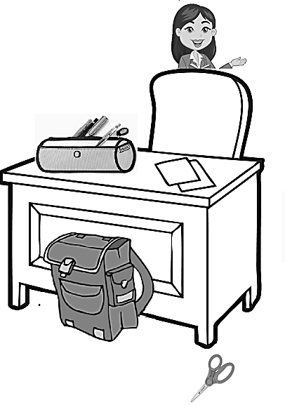

**a) The scissors are ____________________ the desk.**

**b)The schoolbag is ____________________ the desk.**

**c) The pencil case is ____________________ the desk.**

**d) The Teacher is ______________________ the chair.**

**e) The pens are ______________________ the pencil case.**

1. Complete the sentences with the appropriate **Possessive Adjective**:

**a)**This is (I)_________________ bag.

**b)** (Martha) _____________ classroom is big.

**c)** (Tina and Martha) ____________ school is nice.

1. Write sentences using the **Present Simple** of the **Verb To be:**

**- very nice/ Miss Rachel**

***a) ?***__________________________________________________________?

***b)***🞭*_________________________________________________________.*

***c)*** ✓*_________________________________________________________.*

1. Write sentences using the **Present Simple** of the **verb have got:**

***- Martha/ cat***

***a)*** ?__________________________________________________________?

***b)🞭****___________________________________________________________.*

***c) ✓***_*_________________________________________________________.*

1. Complete with the appropriate **Demonstrative Adjective.**

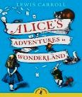

a) _____ book is my favourite.



b) _____ students are happy.

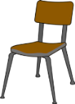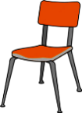

c) _____ chairs are comfortable.

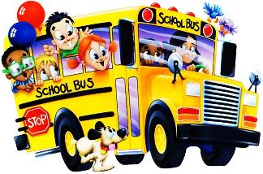

d) _____ school bus is small.

1. Complete or write sentences with the appropriate form of the verb **THERE TO BE :**

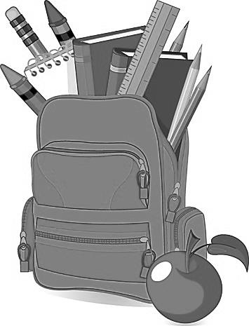

**a)** ________________________ two books in the schoolbag.

**b)** ________________________ a sharpener in the schoolbag.

**c)** ____________________________? Yes, there are two notebooks in the schoolbag.

1. Draw and write what you have got inside your pencil case:

(You can also tell about your /name /age/(…) favourite school subject…)

**-------------------------------------------------------------------------------------------------------------------**

**-------------------------------------------------------------------------------------------------------------------**

**-------------------------------------------------------------------------------------------------------------------**

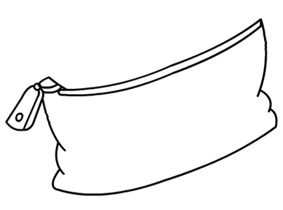**-------------------------------------------------------------------------------------------------------------------**

**-------------------------------------------------------------------------------------------------------------------**

**-------------------------------------------------------------------------------------------------------------------**

**-------------------------------------------------------------------------------------------------------------------**



**From your teacher**

**Olga Nabais Garcias**